Saskatchewan author/teacher offers fundraising opportunity

Hello, I would like to introduce myself. My name is Jocelyn Drozda (M. Ed) and I am a Saskatchewan children’s book author/illustrator and teacher in Regina, Saskatchewan. I have recently released the first three books in a new series, and I would like to partner with teachers, Parent-Teacher Associations, and clubs to use them to raise funds for your schools and groups. I am on my school PTA team and have recognized in current times the limited opportunities for viable fundraising events. As such, I would like to offer my books as an option. As well, I don’t hesitate on disclosing my desire to put these books into schools as a valuable teaching tool—they were inspired by my students and focus on growth mindsets.
My book currently retails for $18.00. I would like to offer you a sale price of $14.00, allowing for a minimum profit of $4.00 per book, as sold to and through your students and families.
I have included a sample template for an informational letter and order form to be sent home with your students. It can be adjusted to add your specific information. Upon receiving a total number of books ordered, I would ship them directly to your school from the distribution company, and send an invoice for payment.

About the Product:
I have written resource material for Oxford University Press, RK Publishing, and First Step Resources, and have offered many teacher workshops over my 20+ years as a teacher.
I am very excited about the release of these new projects, each containing 50+ pages of text with full color illustrations. The intended audience is toddler to grade 4, but many adults are enjoying and learning from the concepts as well, and older students can sell them to relatives and friends as gifts. Additional product information can be found on my website: xanderbooks.com, Facebook page, as well as on Amazon.
In this book series, readers will meet Xander. He is engaging and curious. He is also not perfectly well-behaved at all times, but carries the innocence of a child learning to navigate life. The resulting mishaps and natural repercussions of Xander’s antics lead him to discover better ways of thinking about and responding to the obstacles and events he encounters.
The story is told in first-person, with the imaginative language of a young child. The colorful text is humorous and recognizable to parents and teachers alike, and does not shy away from larger, interesting words with which our little ones often surprise us.
The intent of this series is to develop an awareness of how we think about and react to life’s situations. This will open doors of conversation with children (and adults alike) to help them recognize and strengthen their mental and emotional processing skills and discover that healthy mindsets can be developed, but also need to be practiced. Consciously choosing how we think about things helps guide our daily decisions and choices in both low and high impact situations. This can lead to positive behavior patterns that improve both our overall mental and emotional health and our interactions with others as we journey life’s path.
Explore our website xanderbooks.com for helpful printable lesson plans and activities for teachers, contests and more!

If you are interested in participating in this program, please contact me to receive any additional information.
Email - jdrozda@myaccess.ca (306) 527-9949

Dear parents and students:
We are pleased to offer you an opportunity to partner with a Saskatchewan author/teacher in a unique fundraising event to help raise money for our school. Buy some books and support your school. What a great partnership!
The book series will introduce Xander. He is engaging and curious. He is also not so perfectly well-behaved at all times, but carries the innocence of a child learning to navigate life. The resulting mishaps and natural repercussions of Xander’s antics lead him to discover better ways of thinking about and responding to the obstacles and events he encounters.
In the book, “I Don’t Want to! (but I will),” Xander learns to acknowledge that we don’t necessarily have to like doing everything we are responsible to do, but we can choose to do these things anyway. In doing so, we continue to grow toward reaching emotional maturity.
In the book, “The Now Thing,” Xander comes to terms with the necessity of keeping his mind focused on what he is doing at the present time. He discovers that when he allows his thoughts to jump too far ahead, he misses both important information, and the enjoyment of life’s experiences.
In the book, “What If?” Xander begins to understand that he doesn’t have to allow thoughts of all the bad things that can happen in different situations to overtake him. These uncontrolled thoughts are, in fact, the culprits of his tummy aches.

Reader reviews:
How I wish Xander was around when MY boys were little! He is a highly engaging character that I believe most children will easily relate to. Reading is SUCH a beneficial activity to do with young children, both at home and in the classroom and this is NOT your average storybook! From my experience, reading material containing such profound life lessons are pretty rare. Children and adults alike will be eagerly awaiting each new release to see what their friend Xander is up to next! -M. Hastings (Homeschooling parent of two grown sons and educational assistant)

All I have to say is “self-control” when my child is getting a little crazy and he will stop what he’s doing (usually recite the passage from the book), and calm right back down. The book is one of his favorites.
- Ryan

Xander Book Sale Fund Raising Order Form

Student Name __________________________ Teacher __________________ Grade___
Return Date ______________________
Purchaser Name: | Quantity:  I Don’t Want to | Quantity:  The Now Thing | Quantity:  What If? | Book price:  ($18.00 each)  Total amount collected for each purchaser  [$18.00 X total number of books ordered per purchaser]
 |  |  | Total amount collected:
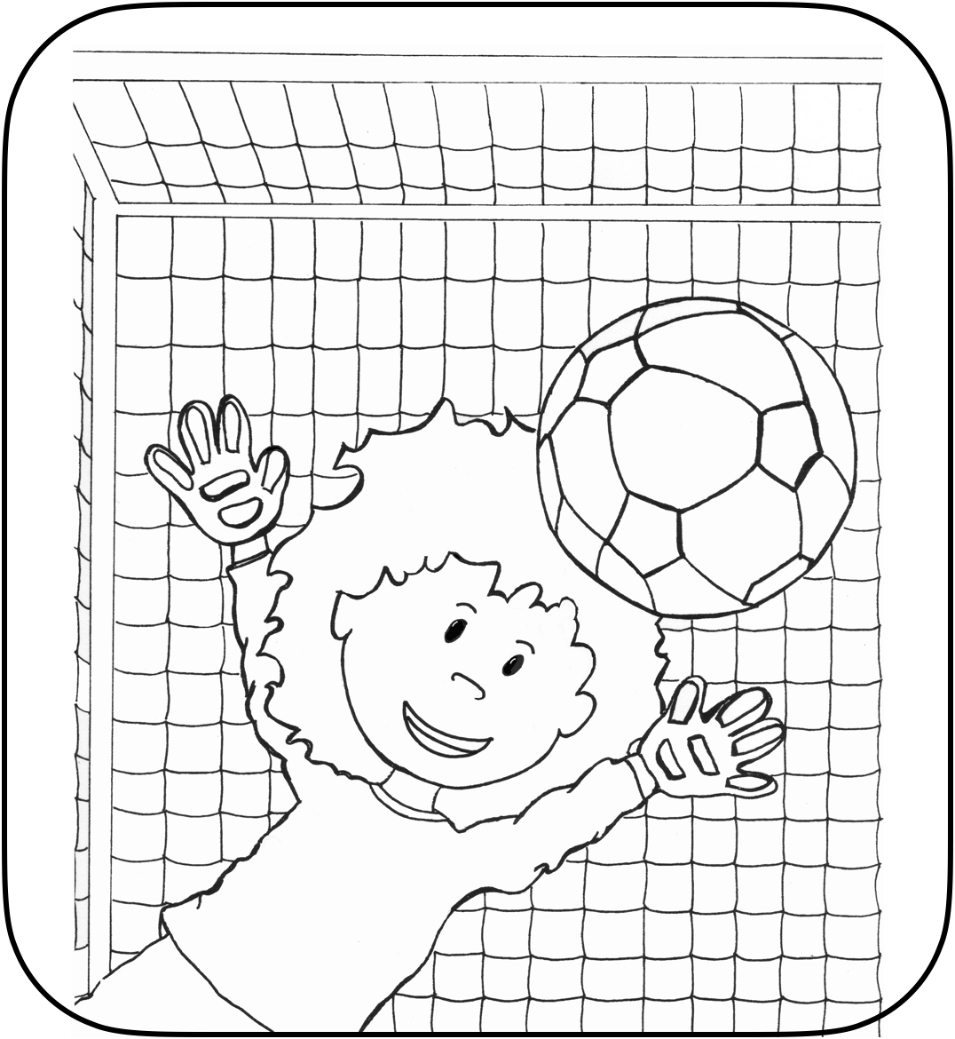 Check out our website
Xanderbooks.com for book information, exciting activities and contests!

